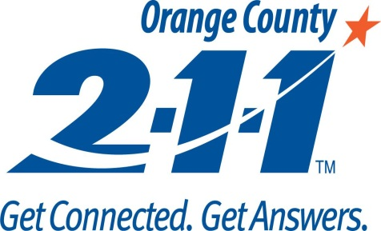

2-1-1 Orange County
1505 E 17th Street Ste. 108, Santa Ana, CA 92705
(714) 288-4007, OCHMIS.org
Homeless Management Information System (HMIS)
User Revocation of Access Form

This Client Revocation of Access form is to notify the HMIS System Administrator that all access to the HMIS system to be revoked for the following employee.
Agency Name: |  | Reason for Revoking Access (mark with ‘X’):
 |  |  | Employee no longer works for agency
Name of Employee: |  |  | Employee no longer uses HMIS
 |  |  | Other:

Authorization
Date Access should be Revoked:

Authorized By (Print Name): |  | Signature:
Job Title: |  | Date:
Phone Number: |  | Email:

Please return this form to 2-1-1 Orange County by email to HMIS-helpdesk@211oc.org
or by fax at (714) 258-7852.

